A Step-by-Step Guide to Formatting Engineering Manuscripts for Elsevier & IEEE
A practical walkthrough for PhD scholars and engineering authors
Let me say this upfront: formatting will not get a weak paper accepted. But it can get a strong paper bounced at the technical check, and losing two weeks that way hurts. This guide follows the order you will actually meet things: template, structure, equations, figures, references, and a final check (Fig. 1).
One rule beats everything below: the journal's Guide for Authors [1], or the conference call for papers, always wins. Treat this guide as a map and the journal page as the final word.
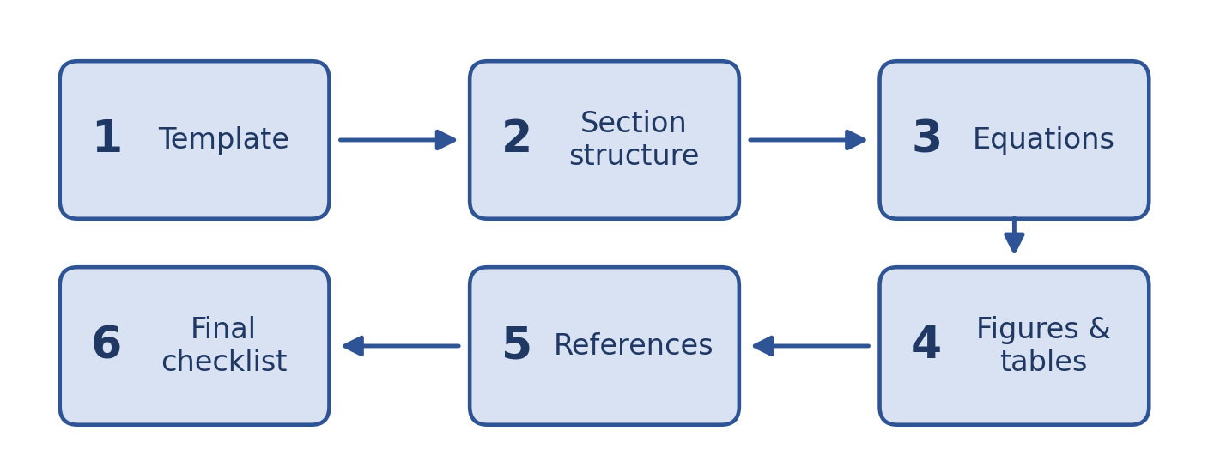
Fig. 1. The six steps, in the order you will meet them.

Step 1: Choosing Between Elsevier and IEEE Templates

Know what you are formatting for
Your target venue decides the publisher, so what you really choose is the file format and how closely you follow the template.
Feature | Elsevier journals | IEEE journals and conferences
Typical layout | Single column, double-spaced, often with line numbers | Two columns, single-spaced
LaTeX class | elsarticle | IEEEtran
Keywords heading | Keywords | Index Terms
References | Set by the journal (numbered or author-year) | Numbered, in order of first citation
Final layout | Typeset by the publisher after acceptance | Often close to what you submit

That last row matters. Elsevier typesets your paper after acceptance, so your manuscript only has to be easy to review. IEEE conference papers are often published almost exactly as you format them, so layout details count for much more (Fig. 2).
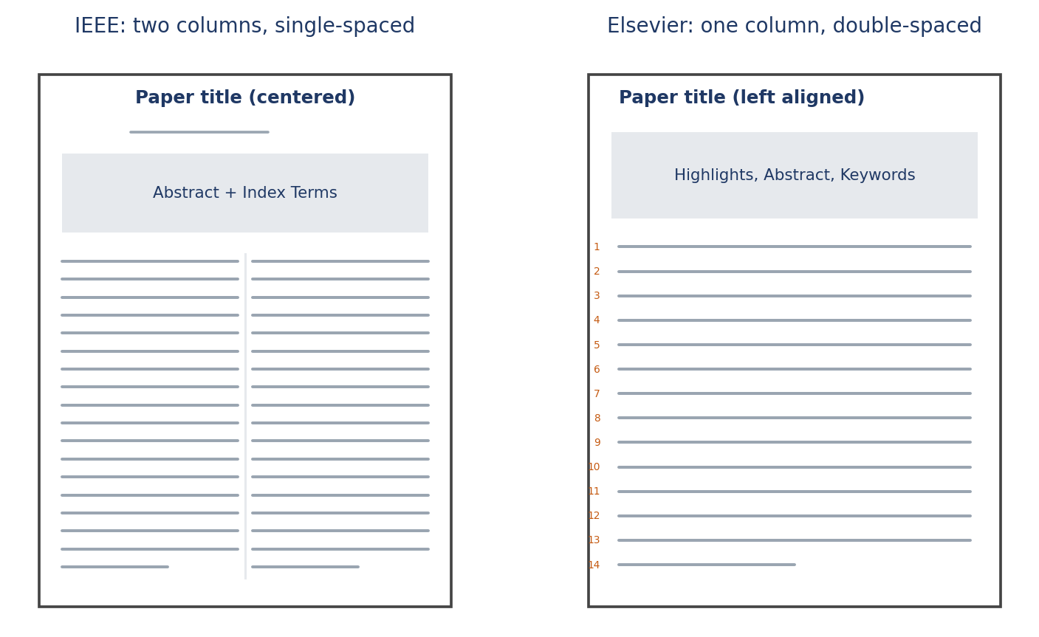
Fig. 2. A two-column IEEE page next to a single-column, double-spaced Elsevier page.

LaTeX or Word?
Pick LaTeX if your paper is equation-heavy (control, signal processing, electromagnetics, mechanics), you want automatic numbering and cross-references, or you share the project through Overleaf or Git.
Pick Word if your paper is mostly experimental, your co-authors do not know LaTeX, or the venue gives you a Word template.

Get the right template
- Elsevier: open the journal homepage, then the Guide for Authors. It links to the current template, usually the elsarticle class [2] or a Word file.
- IEEE: use the template selector in the IEEE Author Center [3] or the one named in your conference call, with the IEEEtran class [4] for LaTeX. Never reuse an old paper's template, because conferences change theirs yearly.
\documentclass[journal]{IEEEtran} % IEEE journal
\documentclass[conference]{IEEEtran} % IEEE conference
\documentclass[review]{elsarticle} % Elsevier submission
And please do not tweak the template. Checkers flag changed margins, font sizes, and repeated \vspace{-...} tricks. If you are over the page limit, cut text.
Colleague tip Choose your venue before you write page one. Moving a half-written paper between templates is where most formatting pain comes from.

Step 2: Preparing Section Structures
Most engineering papers share one skeleton. Check your journal first, since some want a structured abstract or a different section order.

Title, abstract, and keywords
- Title: specific and short, roughly 10 to 15 words.
- Abstract: one paragraph, usually 150 to 250 words. For IEEE, no equations, citations, or undefined abbreviations. Elsevier limits vary, so check.
- Keywords: Elsevier usually wants 4 to 6. IEEE uses "Index Terms", normally alphabetical and drawn from the IEEE Taxonomy where possible.
A good abstract has five parts: the problem, the gap, your method, your main result with a number, and the takeaway.
Colleague tip Write the abstract last. If you cannot state your main result in one sentence with a number in it, the paper is not ready yet.

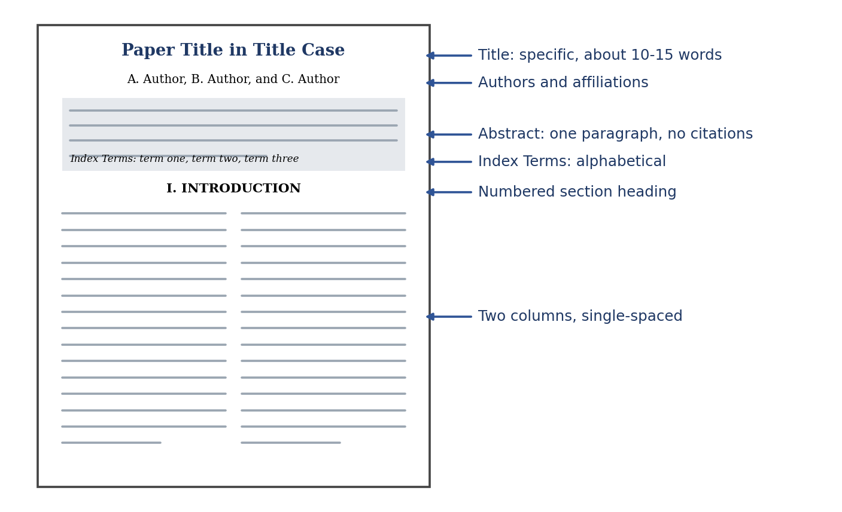
Fig. 3. The first page of an IEEE paper, annotated.

Main sections
- Introduction: context, related work and the gap, your contributions (a short bullet list works well), and a one-paragraph outline.
- Methodology: detailed enough for someone else to reproduce it. Define symbols at first use, and state assumptions, parameters, datasets, hardware, and software versions.
- Results and Discussion: follow the order of your methods. Compare against baselines fairly, report units and uncertainty, and explain why the results look the way they do.
- Conclusion: findings and significance in a paragraph or two, plus limitations and future work. No new results.

Back matter and numbering
Elsevier journals usually ask for a CRediT author statement [5], a competing-interest declaration, funding details, a data availability statement, and, where required, a generative AI declaration. IEEE usually wants acknowledgments and funding in an unnumbered section or first-page footnote, and journals may ask for author biographies.
IEEE numbers sections with Roman numerals (I. INTRODUCTION) and subsections with letters. Elsevier uses decimals (1, 1.1, 1.2). Both templates do this for you.

Step 3: Formatting Mathematics and Equations

Inline versus display math
Use inline math for short symbols and simple definitions inside a sentence. Use display math for anything long, complex, or referenced later. In LaTeX, use the equation or align environments and avoid $$ ... $$, which handles spacing and numbering poorly.
\begin{equation}
E = \frac{1}{2} m v^{2},
\label{eq:kinetic}
\end{equation}

Numbering and punctuation
- Numbers sit in parentheses at the right margin. Always use \label and \eqref so they update by themselves.
- IEEE writes "(1)" or "equation (1)", and "Equation (1)" at the start of a sentence [6]. Elsevier accepts "Eq. (1)" or "Equation (1)". Pick one and stay consistent.
- Equations are part of sentences, so punctuate them. A "where" line below an equation is lowercase and continues the same sentence (Fig. 4).
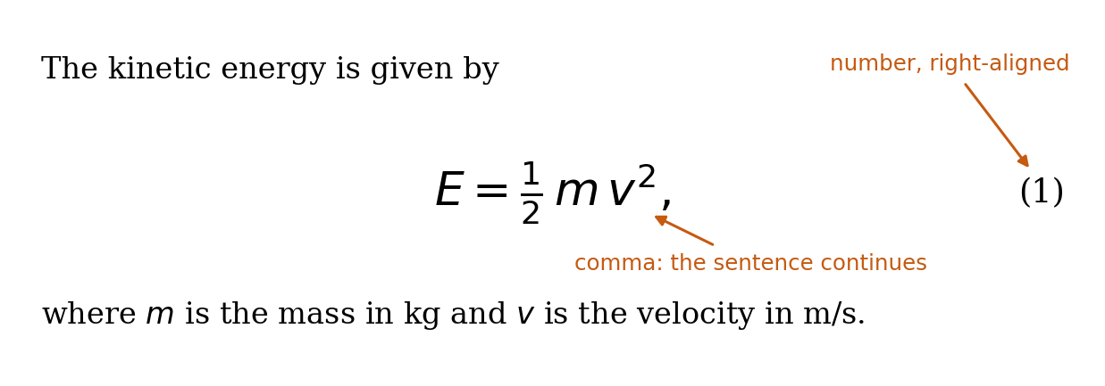
Fig. 4. A display equation with its number, punctuation, and "where" line.

Multi-line equations
Load amsmath [7]. Use align for several equations lined up at the & sign, split for one equation broken over lines, and multline for a long single equation. Skip eqnarray, which has known spacing problems. Break long equations before an operator (+, -, =) and indent the continuation.

Vectors, matrices, and symbols
Choose one convention and keep it for the whole paper. A common engineering choice:
Object | Style | LaTeX
Scalar | Italic | $x$
Vector | Bold lowercase | $\mathbf{x}$
Matrix | Bold uppercase | $\mathbf{A}$
Set | Calligraphic or blackboard bold | $\mathcal{S}$, $\mathbb{R}$

\mathbf does not work for Greek letters, so use \boldsymbol or the bm package. Keep word subscripts upright (V_{\mathrm{out}}), and use siunitx [8] for units, such as \SI{50}{\mega\hertz}. In Word, use the built-in Equation Editor or MathType, never images, and use Insert, then Cross-reference, so numbers update.

Step 4: Figures, Tables, and High-Resolution Visuals

File formats and resolution
- Vector (PDF or EPS) for plots, circuits, and block diagrams. They stay sharp at any size. Export straight from MATLAB, Matplotlib, or Origin instead of taking screenshots.
- TIFF or PNG for photos, microscopy, and screenshots. Use JPEG only for photographs.
Requirements vary, so check the journal. Elsevier commonly asks for 1000 dpi for line art, 300 dpi for halftone, and 500 dpi for combination images [9]. IEEE commonly asks for 600 dpi for line art and 300 dpi for color and grayscale. These apply at final print size. Do not upscale a low-resolution image. Regenerate it instead (Fig. 5).
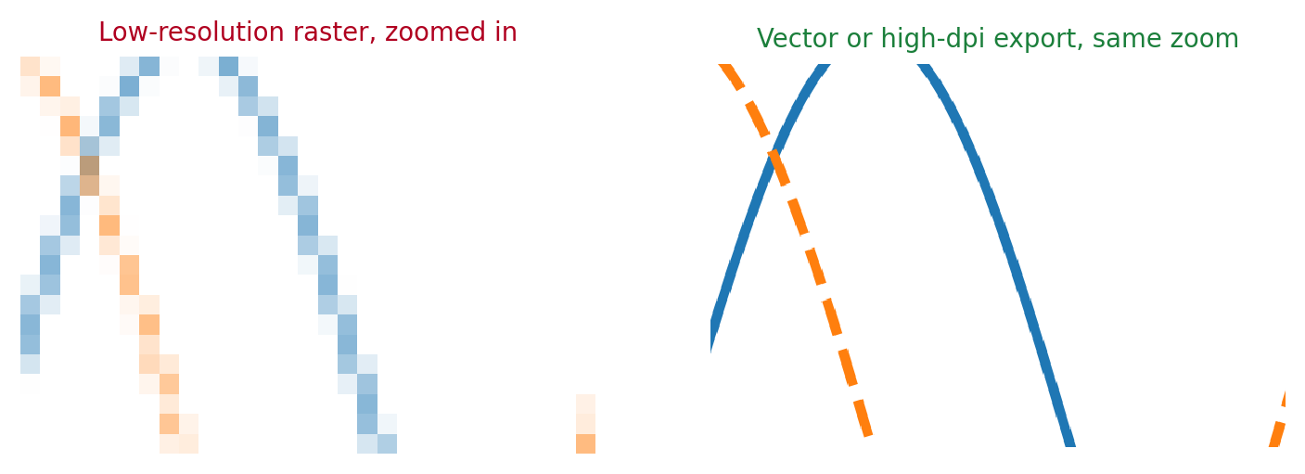
Fig. 5. Same plot, same zoom: low-resolution raster versus a sharp export.
Colleague tip A screenshot of a plot is the most common reason figures get sent back.

Size and readability
- In IEEE two-column layout, a single-column figure is about 3.5 in wide and a full-width one about 7.16 in (use figure* in LaTeX).
- Text inside figures should be about 8 to 10 pt after scaling, with lines that stay visible at final size.
- Make figures readable in grayscale with different line styles and markers, and use a color-blind-safe palette [10]. Label axes with quantity and unit, like "Voltage (V)".

Captions and tables
- Figure captions go below the figure. Table captions go above the table. IEEE prints "TABLE I", Elsevier uses "Table 1" (Fig. 6).
- Cite every figure and table in the text. In IEEE, write "Fig. 1" in running text and "Figure 1" at the start of a sentence.
- Use the booktabs package [11]: horizontal lines only, units in column headers, consistent decimals, best result in bold. Never paste a table as an image.
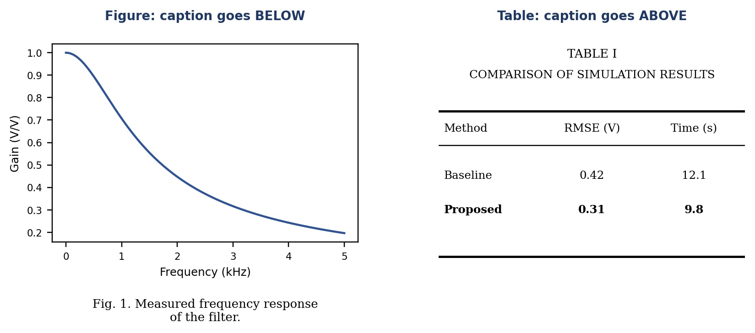
Fig. 6. Caption placement: below for figures, above for tables.
If you reuse a figure from any published paper, even your own, get written permission and credit the source in the caption. Permissions can take weeks.

Step 5: Citation and Reference Management

BibTeX setup
Keep every reference in one .bib file and let the style file format it [12].
\bibliographystyle{IEEEtran} % or elsarticle-num / elsarticle-harv
\bibliography{references} % references.bib
- Compile in this order: LaTeX, BibTeX, LaTeX, LaTeX. If you see [?], rerun, then check the log.
- Protect capitals with braces, such as {MATLAB}, or BibTeX will lowercase them. Use -- for page ranges and include DOIs.

IEEE numerical style
References are numbered in order of first citation, as [1], [2], [3]. Treat the bracket as part of the sentence: "Smith et al. [3] showed", not "[3] showed". Use [1], [3], [5] or [2]-[4] for several sources, and add the cite package to compress ranges (Fig. 7).
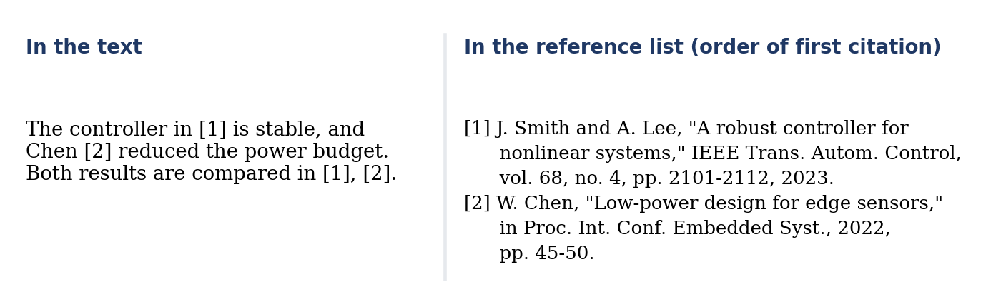
Fig. 7. IEEE style: in-text citations and the matching reference list (illustrative entries).

Elsevier: numbered or author-year
Elsevier has no single style, so read the Guide for Authors and match the style file:
- Numbered: elsarticle-num.bst, shown as [1] and listed in citation order.
- Author-year: elsarticle-harv.bst, shown as (Smith, 2023) and listed alphabetically.
\documentclass[review,authoryear]{elsarticle}
\bibliographystyle{elsarticle-harv}
% \citep{smith2023} gives (Smith and Lee, 2023)
% \citet{smith2023} gives Smith and Lee (2023)

Reference managers and quality checks
Zotero, Mendeley, and EndNote export .bib files, and their Word plugins format citations with a CSL style (search for "IEEE" or the journal name). They often leave messy data like all-caps titles and missing pages, so read your list line by line. Make sure every in-text citation has an entry and every entry is cited.
Colleague tip Add each reference to your .bib file the moment you read the paper.

Step 6: Final Pre-Submission Checklist
Go through this the day before submitting, not an hour before.

Content and template
- Title is clear, the abstract is within the word limit, and keywords are in the right format.
- All required sections are present, abbreviations are defined at first use, and the conclusion matches the results.
- The current template is used and the page limit is met without layout tricks.

Equations, figures, and tables
- Equations are numbered, cross-referenced, punctuated, and every symbol is defined.
- Figures meet the dpi requirement, use vector formats where possible, and stay legible at final size and in grayscale.
- Figure captions are below, table captions above, every item is cited in the text, and permissions for reused figures are on file.

References and declarations
- The citation style matches the journal, and the compiled PDF has no [?] anywhere.
- The cover letter is short and states the novelty. Highlights, graphical abstract, CRediT statement, funding, competing interests, data availability, and any AI disclosure are ready if required.

Final technical checks
- Compile from scratch and fix warnings that matter, especially overfull boxes.
- Read the final PDF start to finish, not just in your editor, and confirm fonts are embedded (IEEE PDF eXpress checks this for many conferences).
- Spell-check everything, including text inside figures, and ask a colleague outside the project to read it once.
Good formatting will not rescue a weak paper, but bad formatting can slow down a strong one. Set up your template, figures, and references properly once, and you can spend your energy on the science.

References
[1] Elsevier, "Guide for Authors," available on each journal's homepage at sciencedirect.com.
[2] Elsevier, "elsarticle: Class for articles submitted to Elsevier journals," CTAN package documentation.
[3] IEEE Author Center, "Templates for IEEE journal and conference articles," ieee.org.
[4] M. Shell, "How to use the IEEEtran LaTeX class," CTAN package documentation.
[5] A. Brand, L. Allen, M. Altman, M. Hlava, and J. Scott, "Beyond authorship: Attribution, contribution, collaboration, and credit," Learned Publishing, vol. 28, no. 2, pp. 151-155, 2015.
[6] IEEE, "IEEE Editorial Style Manual for Authors," IEEE Periodicals.
[7] American Mathematical Society, "User's guide for the amsmath package," CTAN package documentation.
[8] J. Wright, "siunitx: A comprehensive (SI) units package," CTAN package documentation.
[9] Elsevier, "Artwork and media instructions," Elsevier Author Resources.
[10] B. Wong, "Points of view: Color blindness," Nature Methods, vol. 8, no. 6, p. 441, 2011.
[11] S. Fear, "Publication quality tables in LaTeX (booktabs)," CTAN package documentation.
[12] L. Lamport, LaTeX: A Document Preparation System, 2nd ed. Reading, MA, USA: Addison-Wesley, 1994.

